**Fatima Jinnah Women University**

Department of Software Engineering

**LAB 9**

**Name:** Raifa Khalid

**Reg. no:** 2020-BSE-024

**Section:** A

**Semester:** Fourth

**Course:** Data Base (LAB)

**EXAMPLES:**

**EXAMPLES:**

*Querying Data Dictionary:*

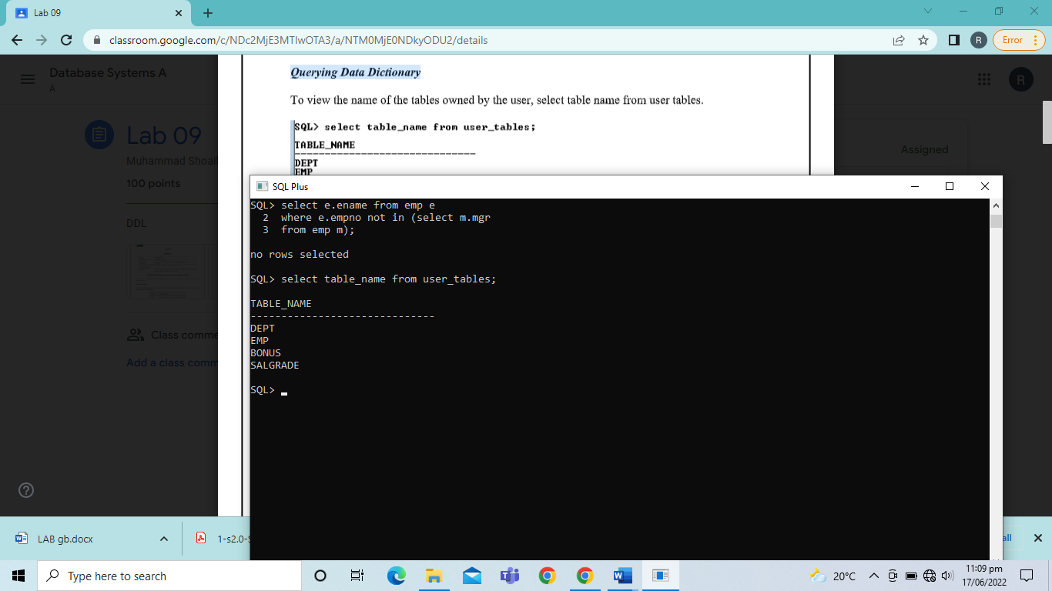

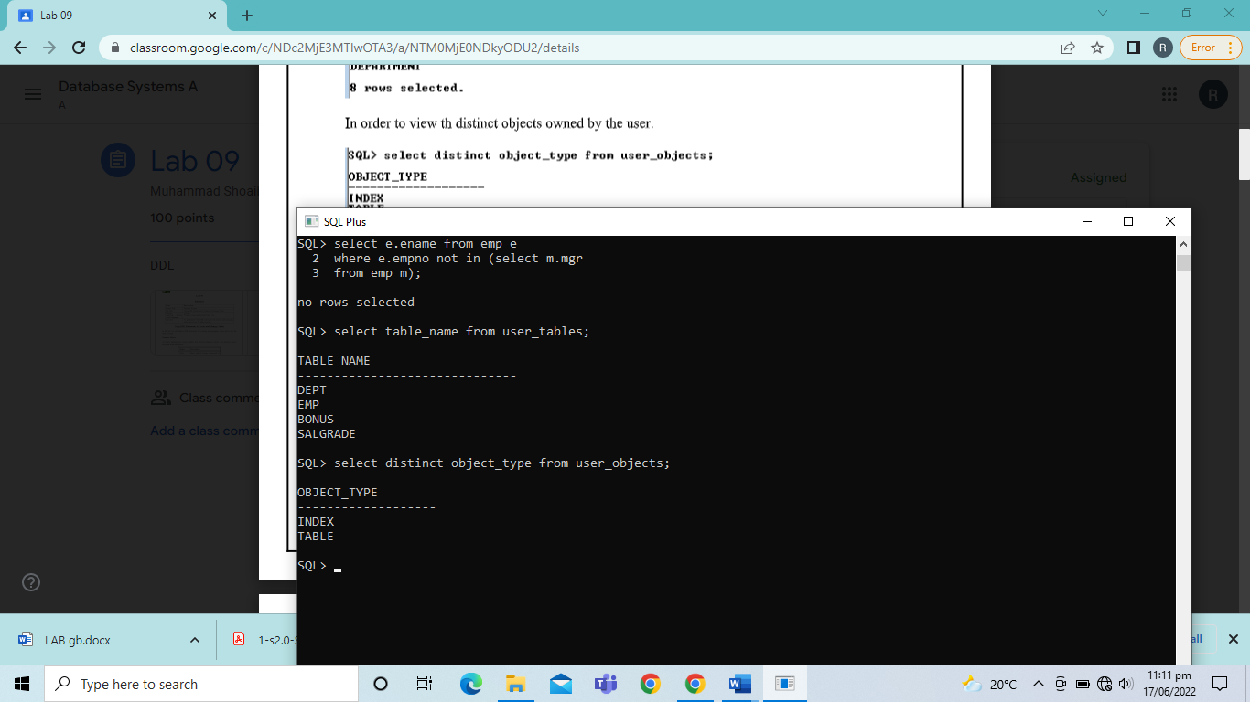

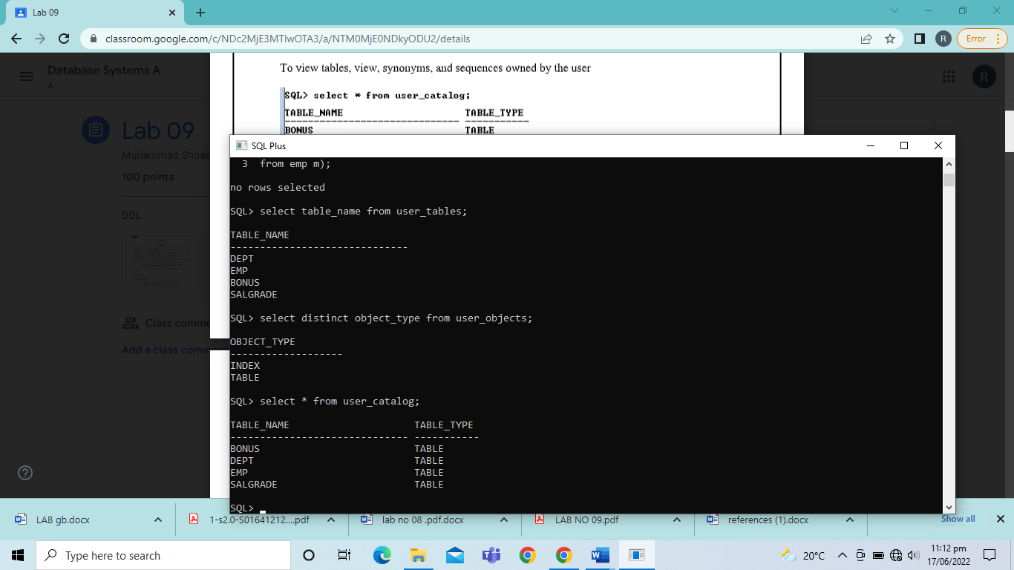

*Creating Tables:*

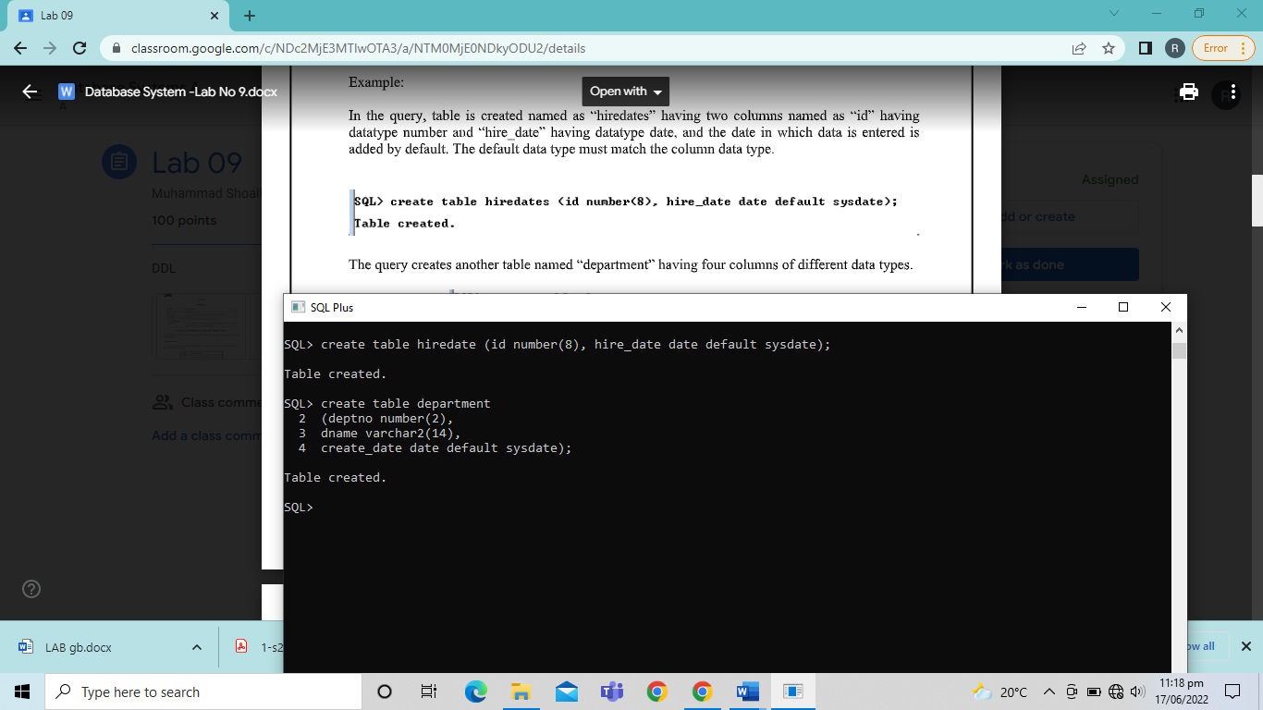

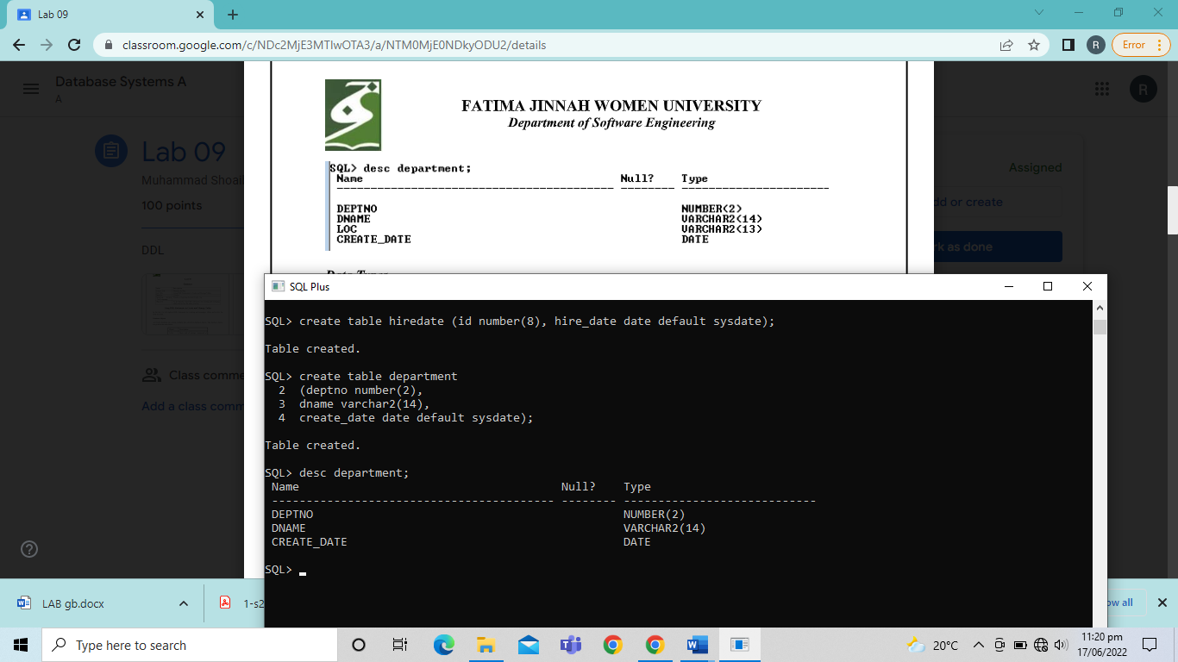

*Adding a Column:*

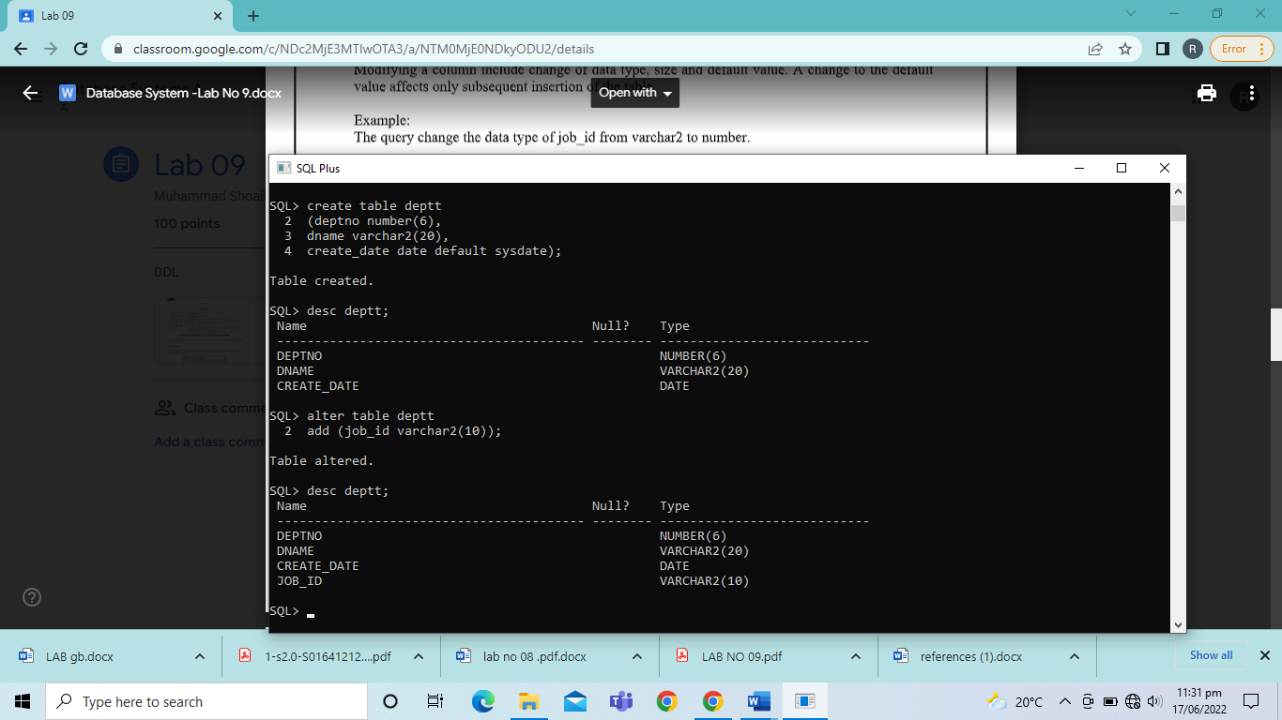

*Modifying a Column:*

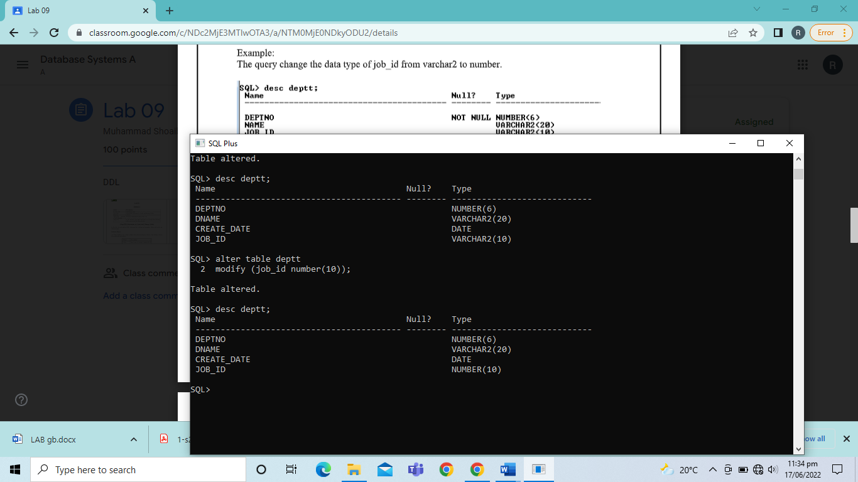

*Dropping a Column:*

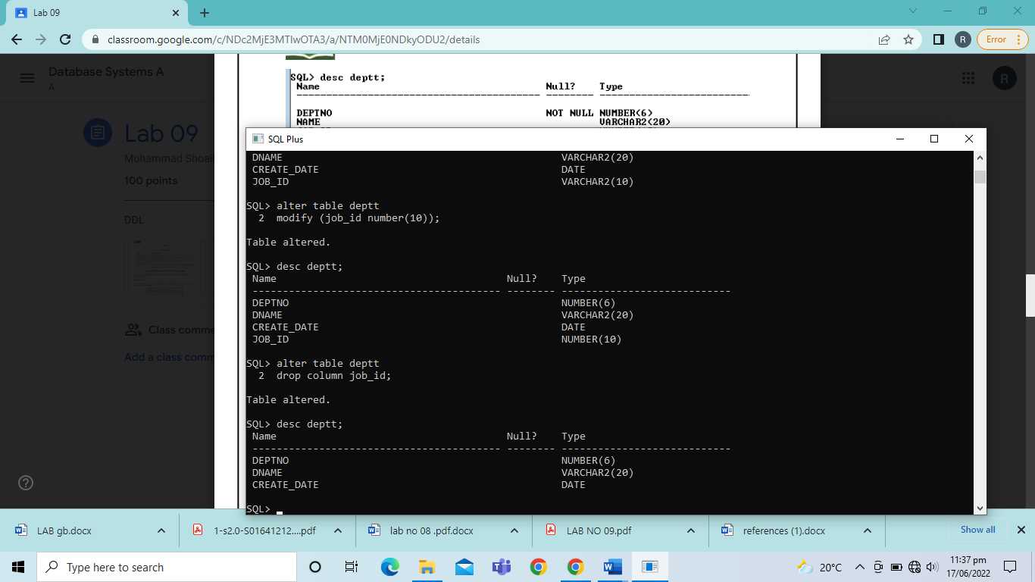

*Dropping Table:*

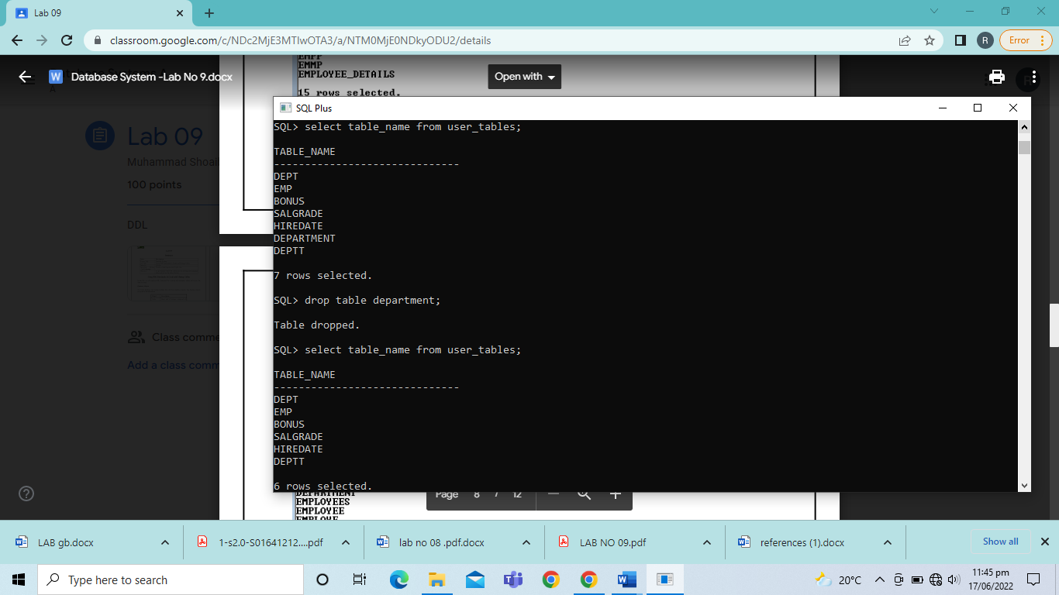

*Changing the Name of the Object:*

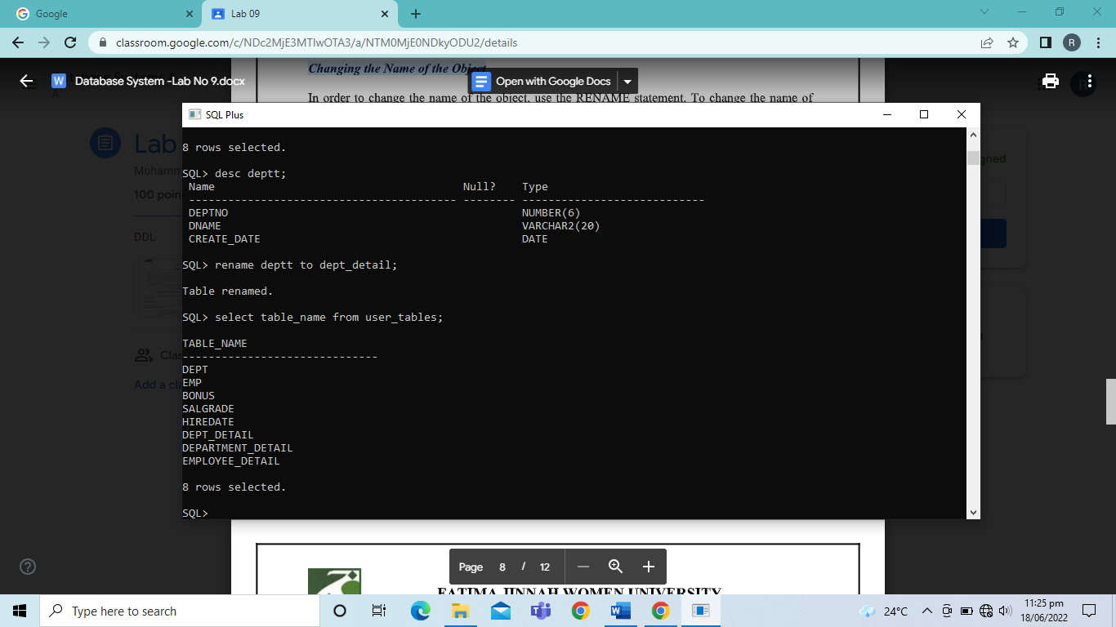

*Truncating Table:*

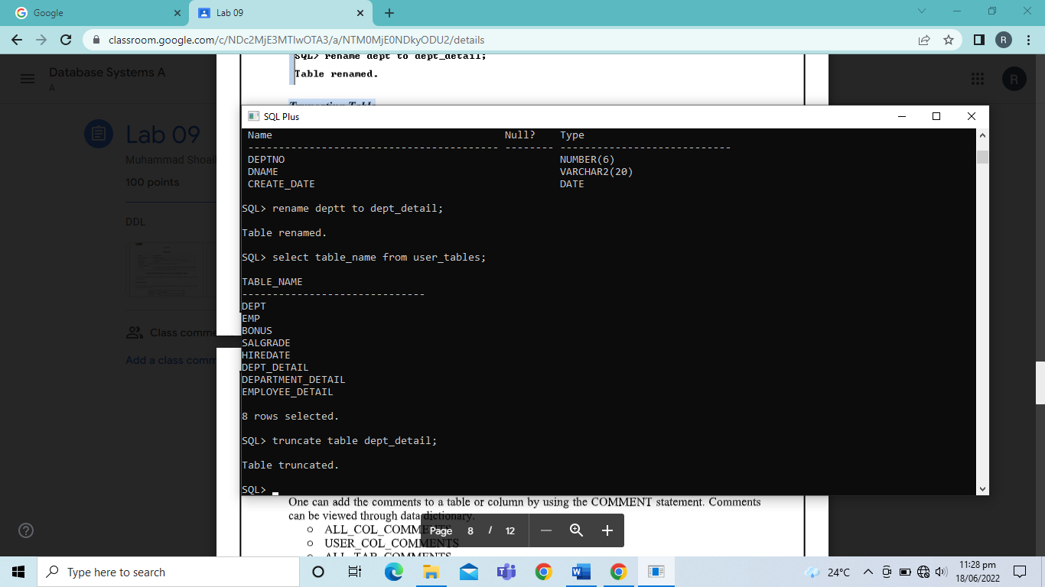

*Adding Comments to the Table:*

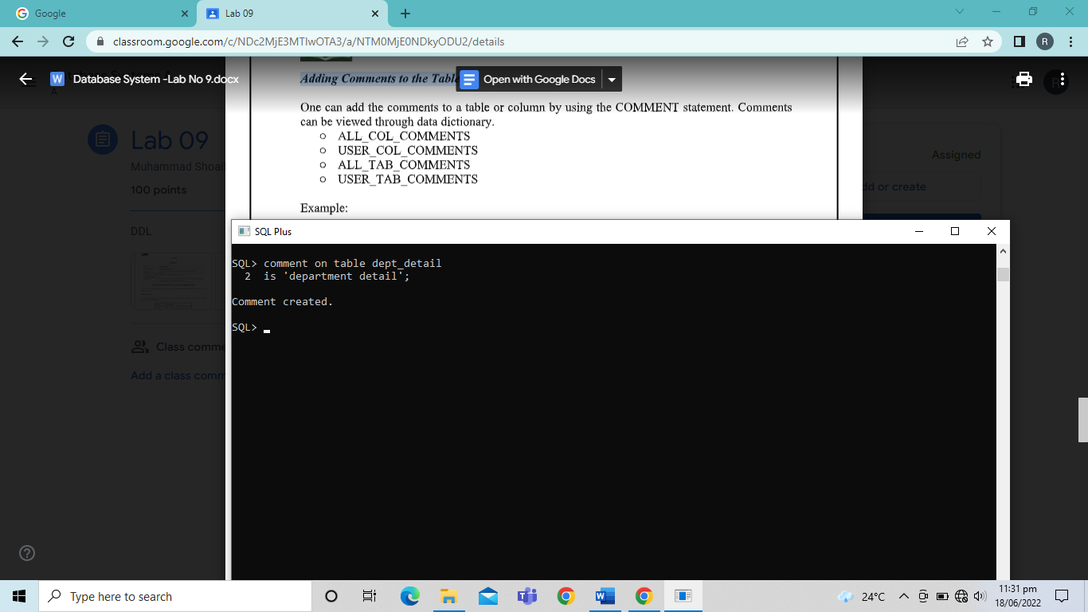

*The SET UNUSED Option:*

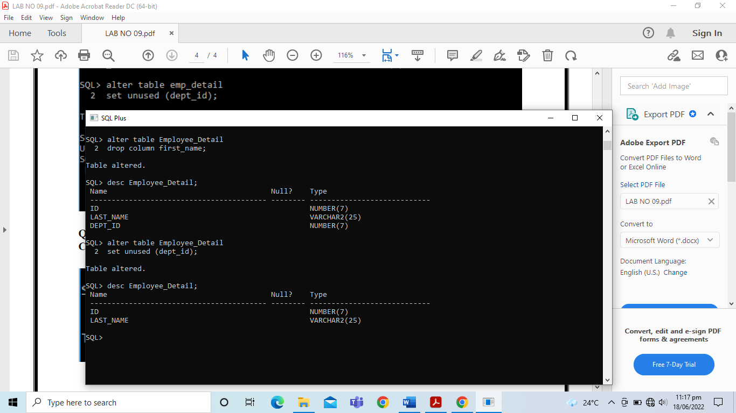

TASKS

1. Create “Department_Detail” table with the schema given below. Conform that the table is created.

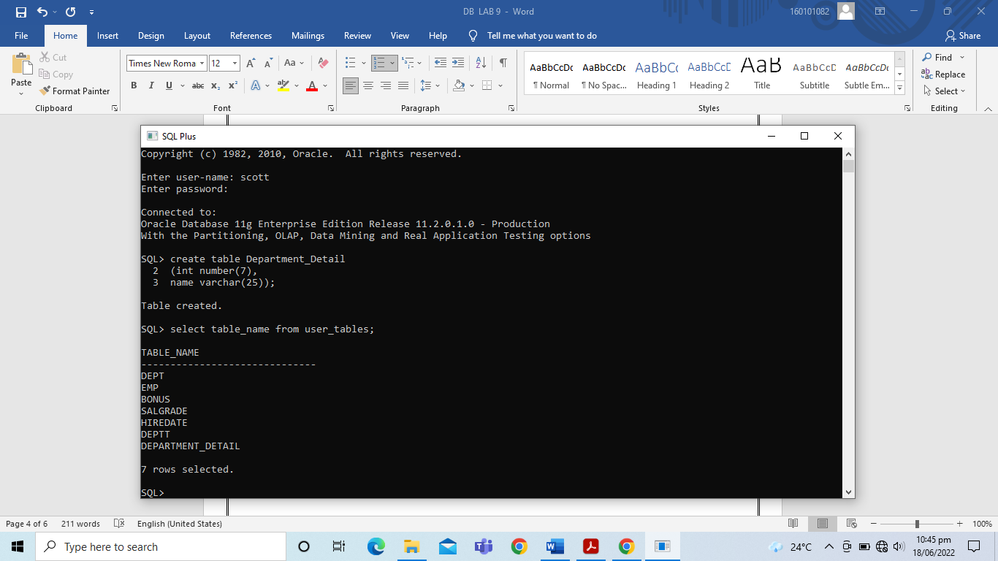

1. Create the “Employee_Detail” table based on the following table instance chart. Confirm that the table is created.

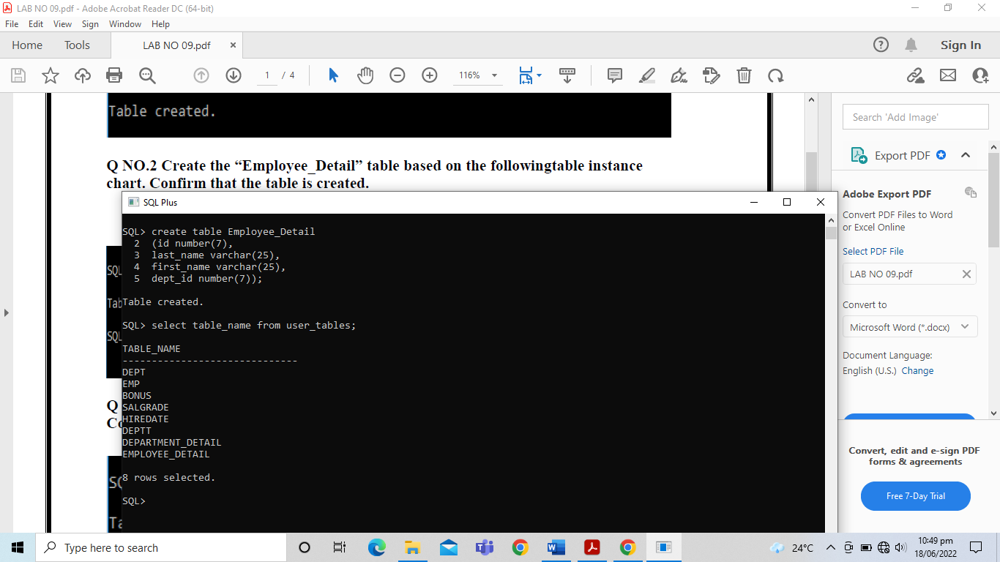

1. Modify the “Employee_Detail” table to allow for longer employee last names. Confirm your modifications.

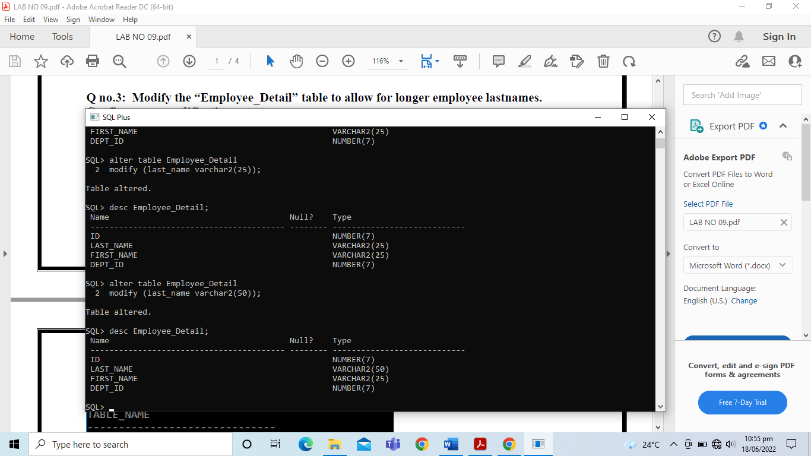

1. Confirm that both tables created above are stored in the data dictionary.

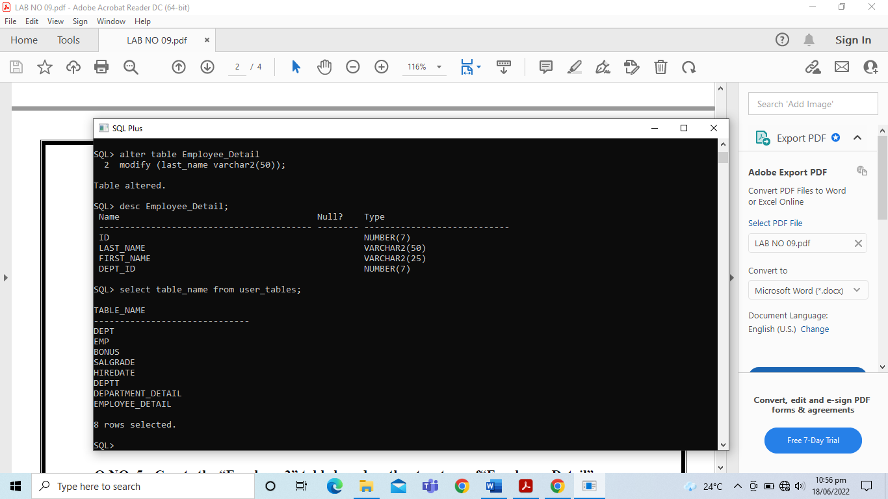

1. Create the “Employee2” table based on the structure of “Employee_Detail” table.

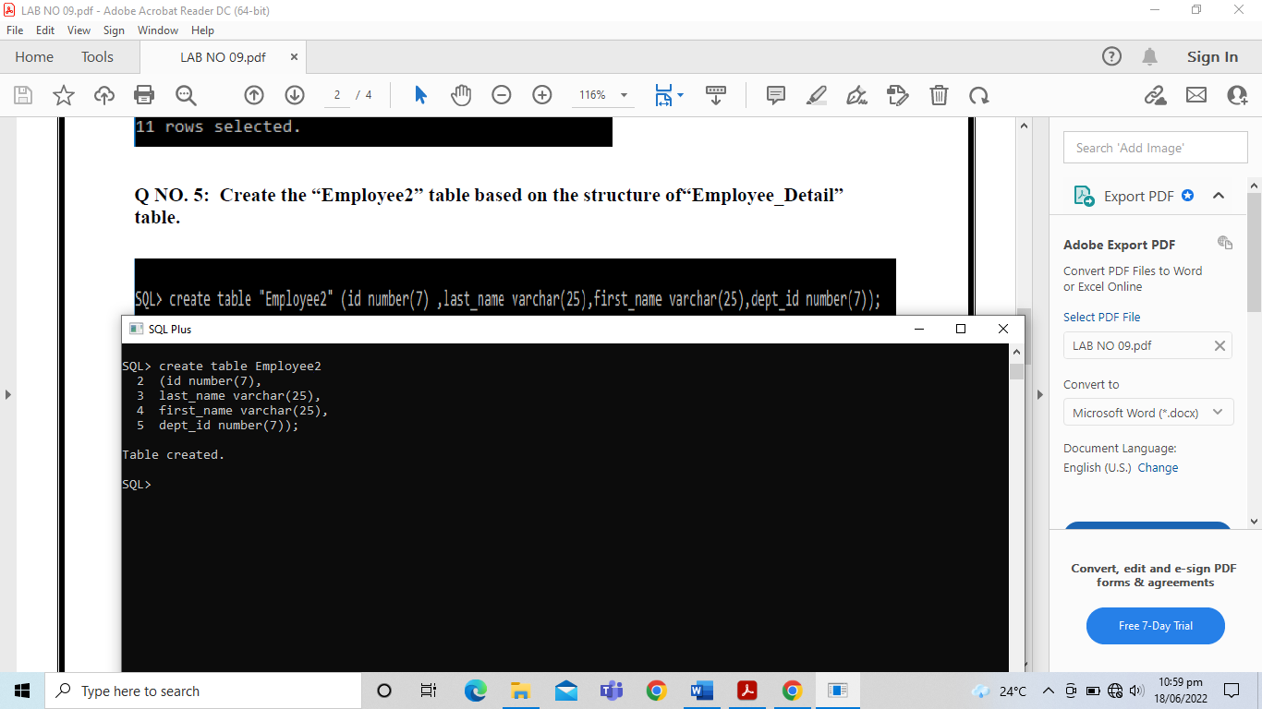

1. Drop the Employee_Detail table.

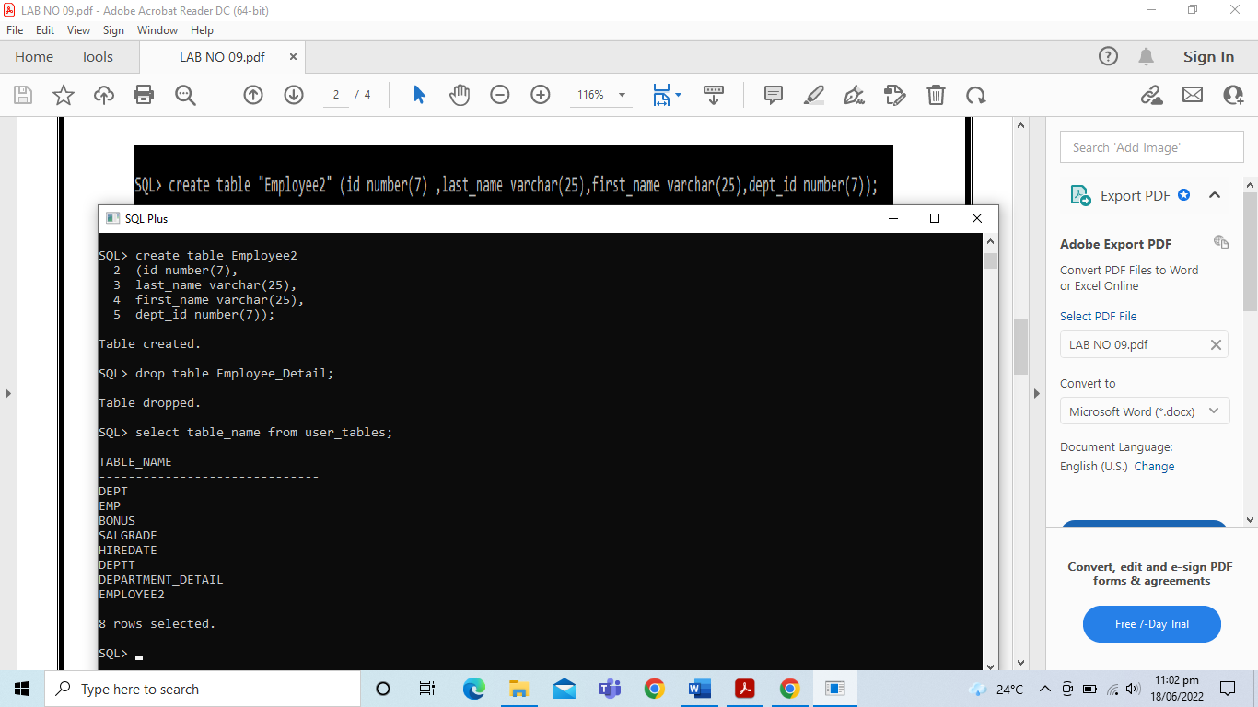

1. Rename the “Employee2” table as “Employee_Detail” table.

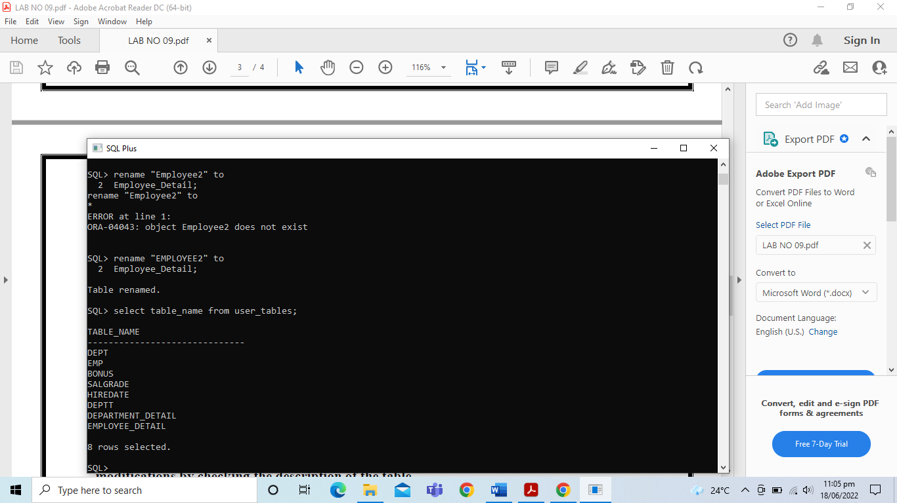

1. Add a comment to both table definitions describing the tables. Confirm your additions in the data dictionary.

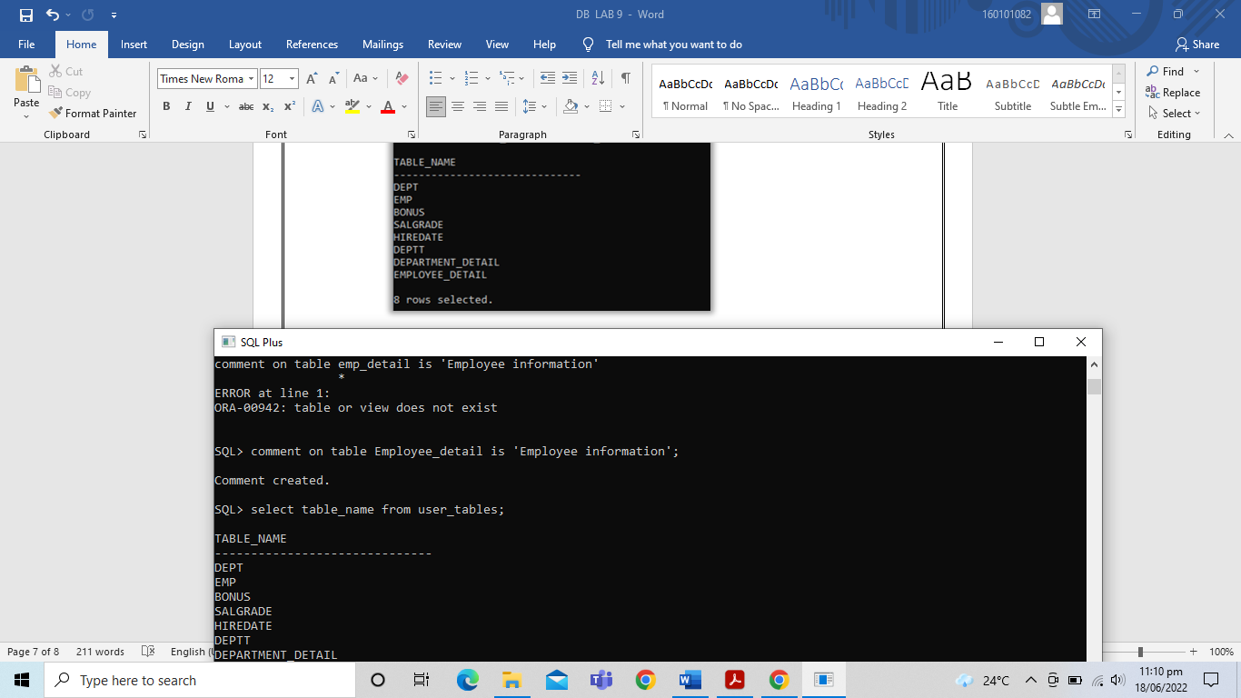

1. Drop the First_Name column from the Employee_Detail table. Confirm your modifications by checking the description of the table.

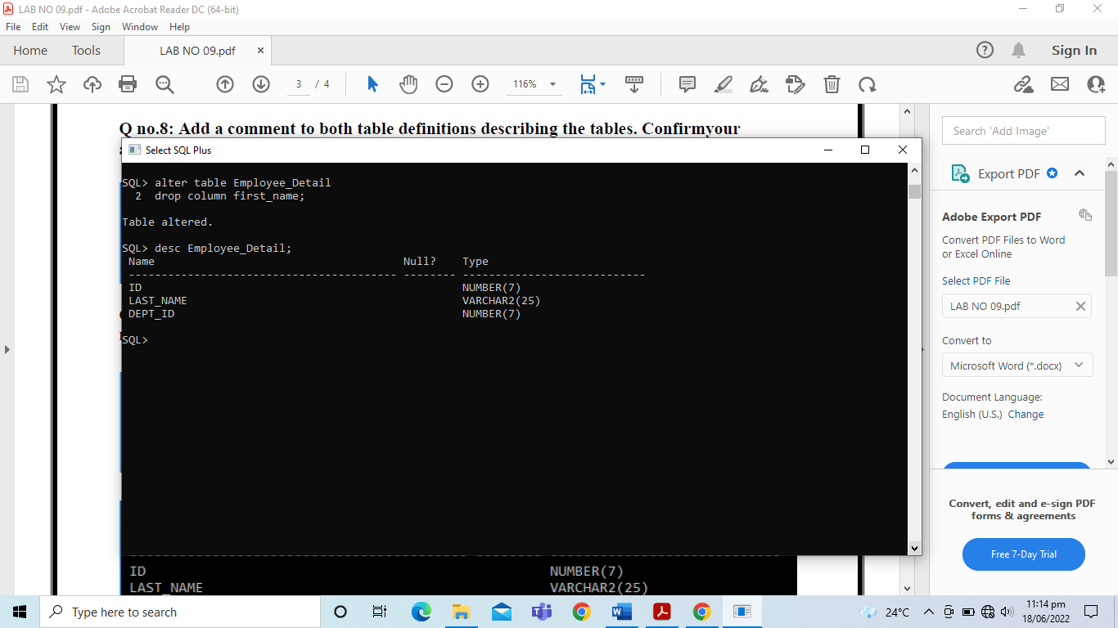

1. In the Employee_Detail table, mark the DEPT_ID column in the Employee_Detail table as unused. Confirm your modifications by checking the description of the table.



1. Drop all the UNUSED columns from the Employee_Detail table. Confirm your modifications by checking the description of the table.

